HOTEL REVENUE ANALYSIS
MODULE 5
1. Objective
This module develops a Revenue Strategy Dashboard designed to help General Managers and Revenue Managers make informed pricing and revenue decisions. The dashboard combines room revenue, ancillary services, upsell performance, and dynamic pricing models into one integrated view.
By using Power BI, Power Query, DAX measures, and What-If parameters, the dashboard enables scenario testing that balances demand, occupancy, and pricing sensitivity. The outcome is a tool that improves RevPAR, total revenue, and guest value through data-driven insights.
2. Tables and columns
2.1 Ancillary Transactions Table
To capture non-room revenue, an Ancillary_Transactions table was created in Power Query. It simulates services such as Spa, Dining, and Airport Pickup, linked directly to guest bookings.
Key Columns:
- TransID – unique transaction code
- BookingID – connects ancillary spend to room bookings
- CustomerID – guest identifier
- Date – service usage date
- ServiceType – Spa, Dining, or Services
- Item – specific service (e.g., massage, buffet dinner)
- Quantity – number of services used
- Amount – revenue generated
This table provides the foundation for upsell analysis and non-room revenue contribution.
2.2 Power Query Formula
let
// Load Bookings table
Source = Booking,

// Filter valid bookings
ValidBookings = Table.SelectRows(Source, each [CheckInDate] <> null and [CheckOutDate] <> null),

// Add ServiceType using CustomerID length + CheckInDate day
WithServiceType = Table.AddColumn(ValidBookings, "ServiceType", each
let r = Number.Mod(Text.Length([CustomerID]) + Number.From(Date.Day([CheckInDate])), 6)
in if r = 0 then "Spa"
else if r = 1 then "Dining"
else if r = 2 then "Services"
else if r = 3 then "Gym"
else if r = 4 then "Bar"
else "Laundry"),

// Add Item based on ServiceType
WithItem = Table.AddColumn(WithServiceType, "Item", each
if [ServiceType] = "Spa" then "Swedish Massage"
else if [ServiceType] = "Dining" then "Buffet Dinner"
else if [ServiceType] = "Services" then "Airport Pickup"
else if [ServiceType] = "Gym" then "Personal Training Session"
else if [ServiceType] = "Bar" then "Cocktail Evening"
else "Express Laundry"),

// Add Quantity randomly (1 to 3)
WithQuantity = Table.AddColumn(WithItem, "Quantity", each
1 + Number.Mod(Text.Length([BookingID]) + Number.From(Date.Day([CheckOutDate])), 3)),

// Add Amount based on ServiceType and Quantity
WithAmount = Table.AddColumn(WithQuantity, "Amount", each
let base = if [ServiceType] = "Spa" then 1800
else if [ServiceType] = "Dining" then 1200
else if [ServiceType] = "Services" then 1000
else if [ServiceType] = "Gym" then 1500
else if [ServiceType] = "Bar" then 800
else 600
in base * [Quantity]),

// Add Transaction Date within stay period
WithDate = Table.AddColumn(WithAmount, "Date", each
let los = Duration.Days([CheckOutDate] - [CheckInDate]),
offset = Number.Mod(Text.Length([RoomTypeID]) + Number.From(Date.Day([CheckOutDate])), los + 1)
in Date.AddDays([CheckInDate], offset)),

// Add TransID
WithIndex = Table.AddIndexColumn(WithDate, "TransID", 1, 1, Int64.Type),
Final = Table.TransformColumns(WithIndex, {
{"TransID", each "ANC" & Text.PadStart(Text.From(_), 5, "0"), type text}
}),

// Select final columns
AncillaryTable = Table.SelectColumns(Final, {"TransID", "BookingID", "CustomerID", "Date", "ServiceType", "Item", "Quantity", "Amount"})
in
AncillaryTable
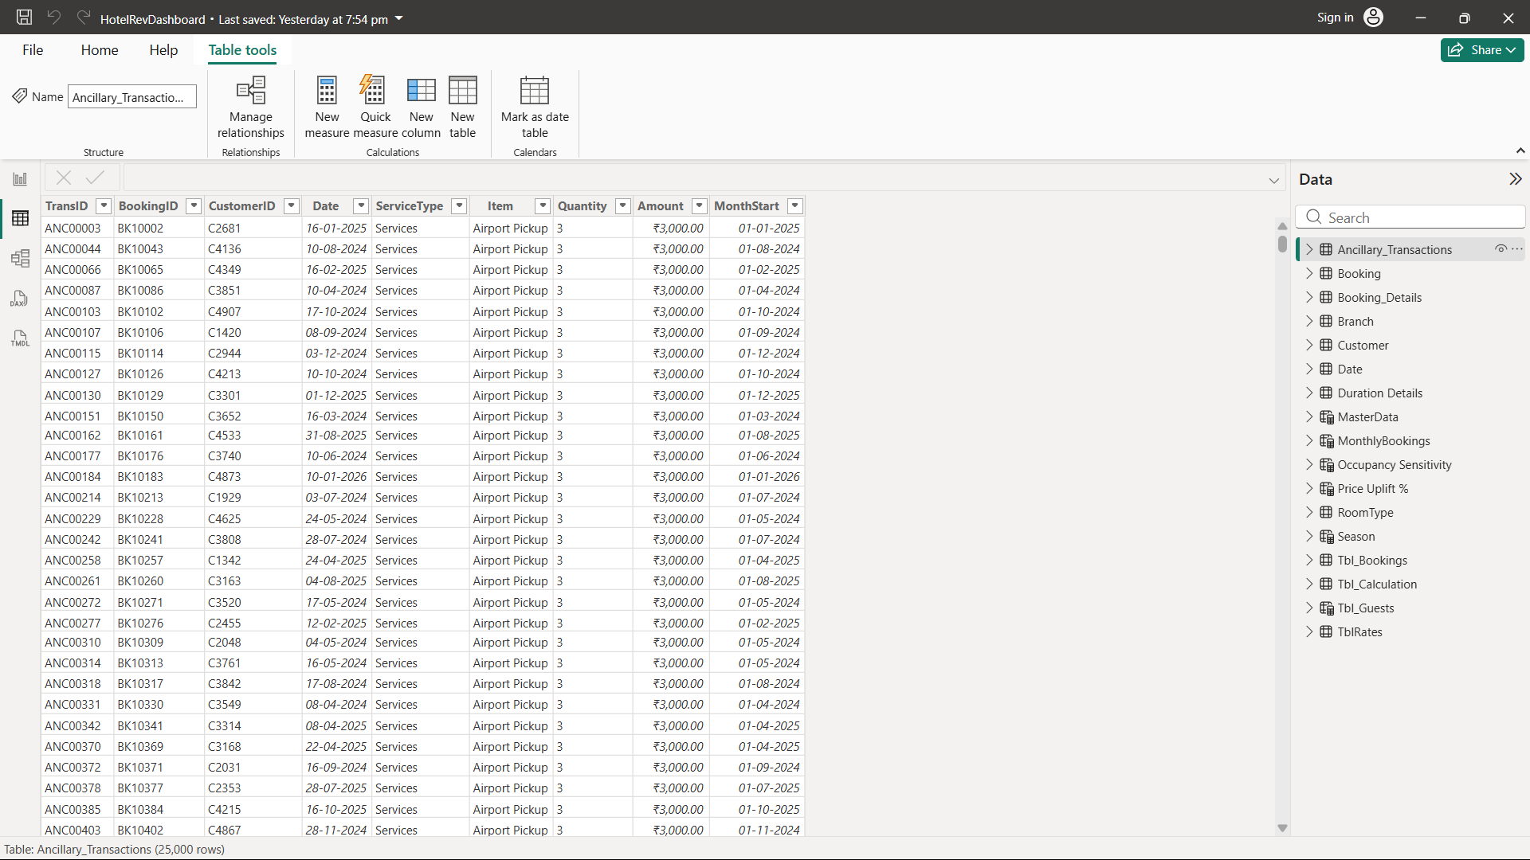
3. Measures
3.1 Ancillary Revenue
DAX
Ancillary Revenue =
SUM(Ancillary_Transactions[Amount])
Calculates total ancillary revenue.
3.2 Ancillary Revenue per Booking
DAX
Ancillary Rev / Booking =
DIVIDE(
SUM(Ancillary_Transactions[Amount]),
COUNT(Booking[BookingID])
)
Shows average ancillary revenue per booking.
3.3 Upsell Conversion %
DAX
Upsell Conversion % =
DIVIDE(
DISTINCTCOUNT(Ancillary_Transactions[BookingID]),
DISTINCTCOUNT(Booking[BookingID])
)
Measures how effectively bookings are converted into upsell opportunities.
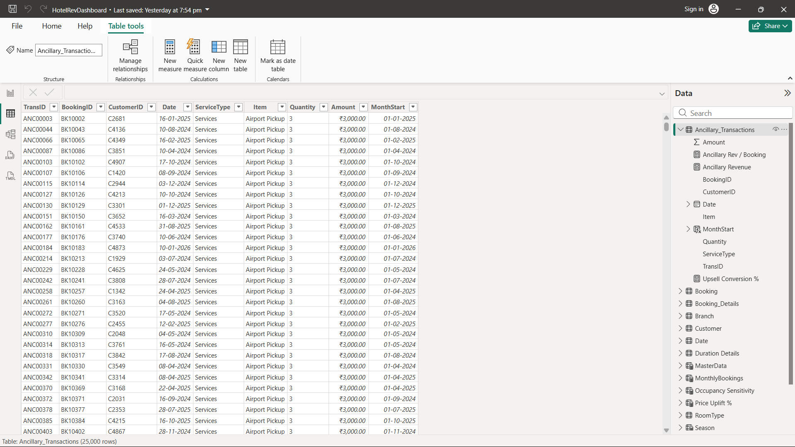
4. Pricing Strategy
4.1 What-If Parameters
- Price Uplift % – simulates discounts or price increases dynamically
- Occupancy Sensitivity Value – models elasticity of demand relative to occupancy
These parameters allow managers to test different pricing scenarios without altering base calculations.
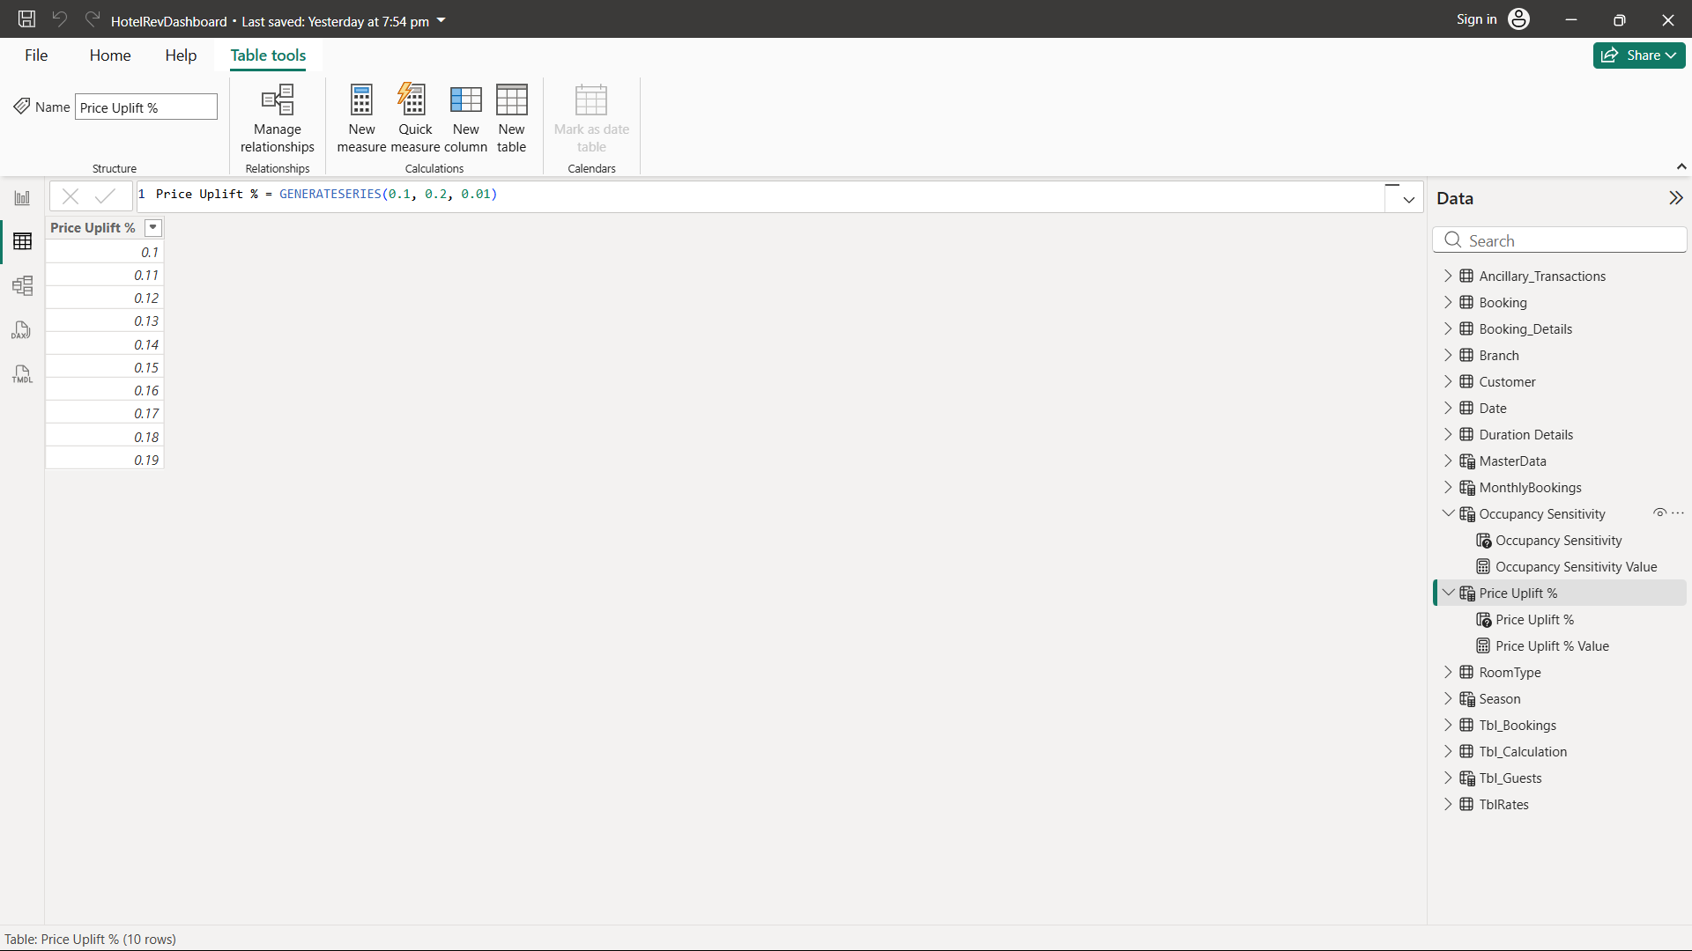
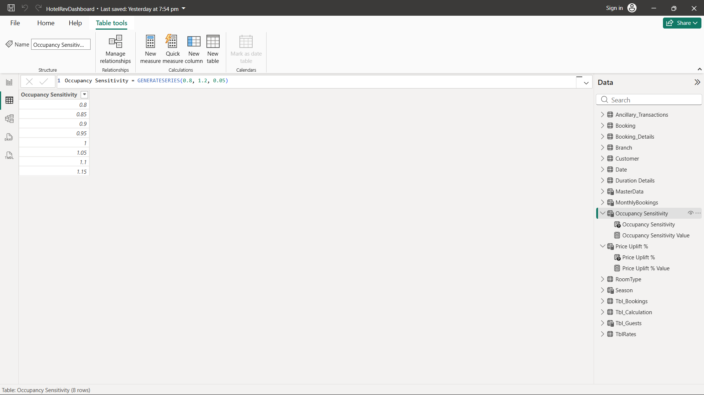
5. Recommended Price Logic
A measure was created to calculate optimized room rates by combining ADR, seasonality, uplift, and occupancy sensitivity.
DAX
Recommended Price =
VAR BaseADR = [DADR]
VAR SeasonAdj =
SWITCH(
SELECTEDVALUE('Date'[Season]),
"High", 0.15,
"Shoulder", 0.05,
"Low", -0.10,
0
)
VAR Uplift = [Price Uplift % Value]
VAR Elasticity = [Occupancy Sensitivity Value]
RETURN
BaseADR * (1 + SeasonAdj + Uplift) * Elasticity
6. Visuals
- Stacked Column Chart – monthly ancillary revenue by service type (Dining, Spa, Services).
- Monthly Table – service-wise revenue and transaction counts.
- Pie Chart – percentage contribution of each service type to total ancillary revenue.
- Pricing Tier Matrix – recommended prices by room type and season.
- What-If Sliders – interactive controls to simulate pricing scenarios.
Together, these visuals provide a comprehensive view of upsell performance and pricing strategy.
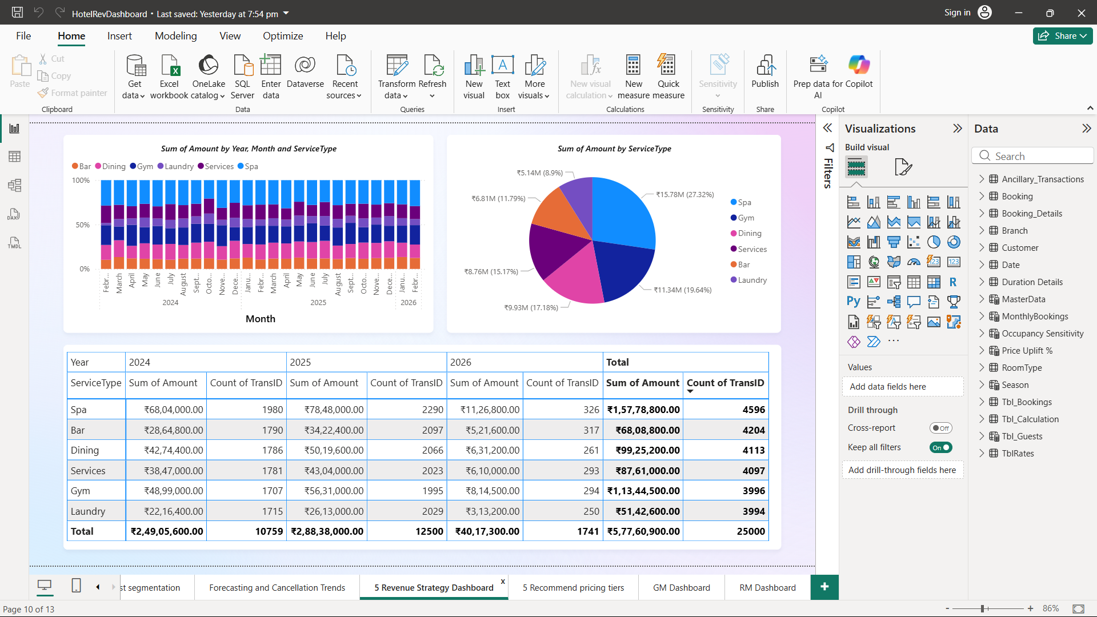
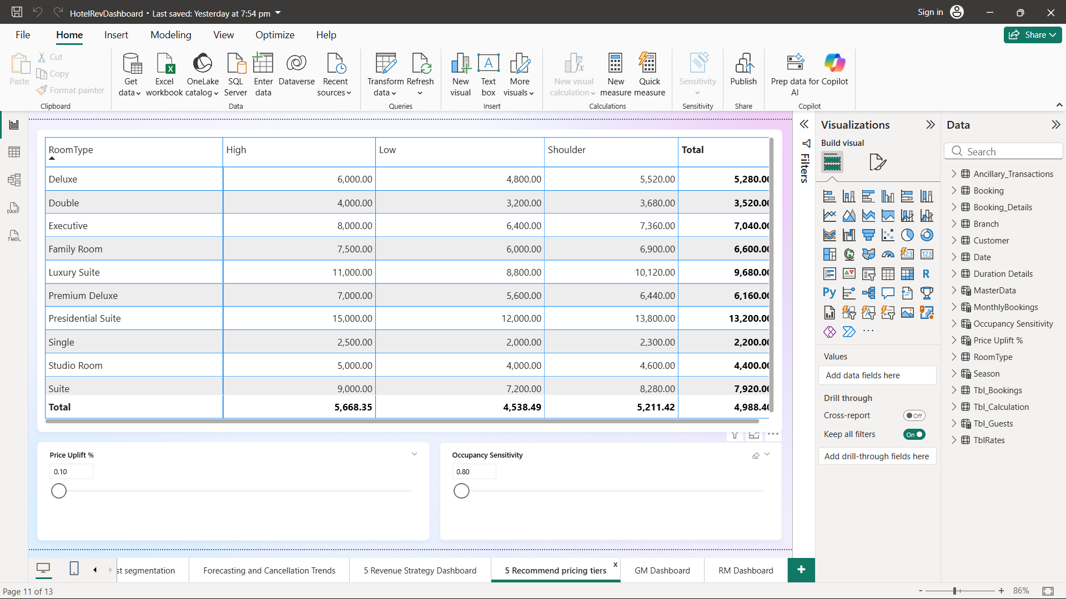
7. Insights
- Ancillary services are a major contributor to overall revenue.
- Upsell conversion varies by customer segment, showing scope for targeted promotions.
- Dynamic pricing adapts rates to seasonality and demand sensitivity.
- Scenario analysis balances ADR growth with occupancy impact.
- Integrating ancillary revenue with pricing strengthens RevPAR optimization.
8. Conclusion
Module 5 integrates ancillary revenue analysis with dynamic pricing into a single Revenue Strategy Dashboard. Using Power Query, DAX, and What-If parameters, the dashboard enables interactive, scenario-driven decision-making.
This equips hotel management with actionable insights to optimize pricing, improve upselling, and maximize revenue in a competitive market.
9. General Manager Dashboard
The General Manager Overview provides a high-level snapshot of overall hotel performance.
- KPI cards display Total Bookings, Average Occupancy %, Guest Satisfaction Score, ADR, and Total Revenue.
- Visuals show revenue contribution by branch, guest mix, booking channel distribution, and customer value segmentation.
- Cancellation rate and guest satisfaction trends help evaluate service quality and booking reliability.
This dashboard enables senior management to quickly assess business health and performance trends.
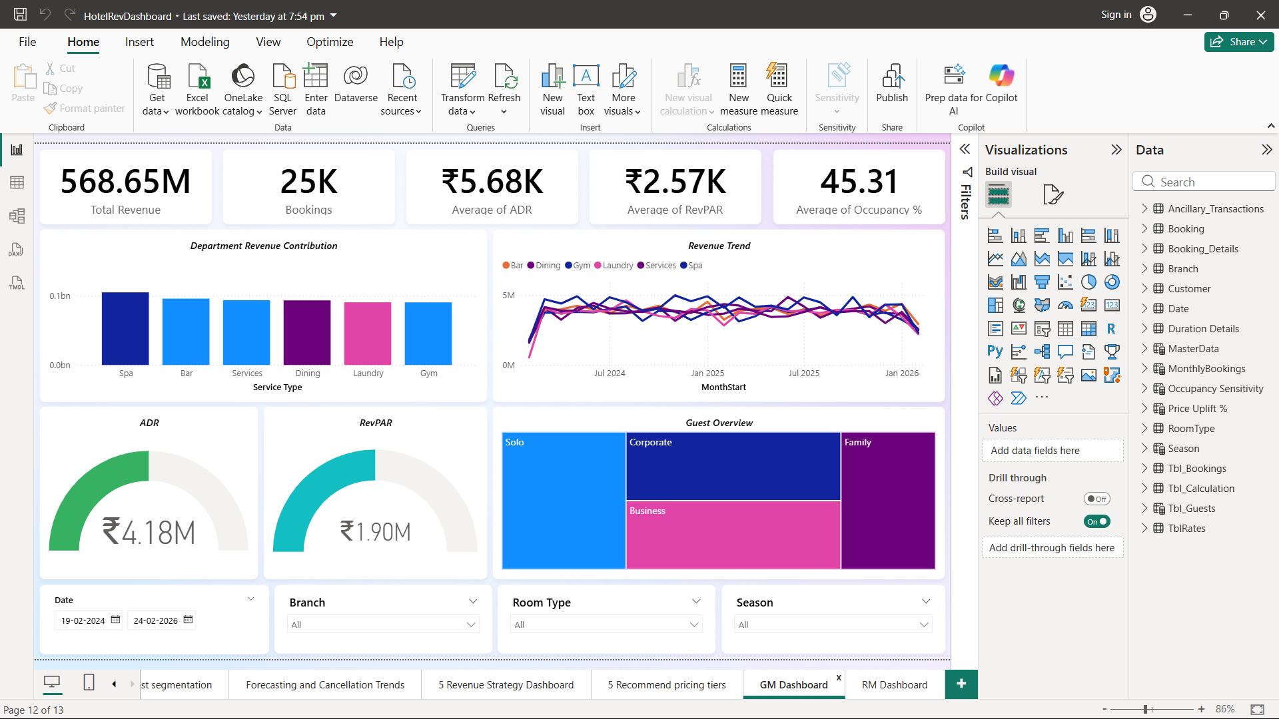
10. Revenue Manager Dashboard
The Revenue Manager Overview focuses on detailed, time-based revenue optimization.
- KPI cards highlight Average ADR, Occupancy %, and Rooms Booked.
- Weekly revenue and cancellation trends help monitor short-term performance.
- Visuals such as day revenue by booking source, weekday vs weekend revenue, and discount impact on revenue support pricing decisions.
- Performance trends assist in adjusting pricing, promotions, and inventory strategies.
